Institute of Grace October 2017 Newsletter
The new school year began for EGF primary school with several major steps forward. We have added four teachers to the staff, plus several part time instructors for our new 7th grade curriculum. Additional classrooms have been added in the first floor of the school building. We now have classes on all three floors, and individual classes for each year group. This has increased our budget for teachers and for the lunch program. We are trusting God to provide the additional funds through our generous supporters. New churches and new individual contributors allow us to step up to meet more of the needs in the community. Also, Principal Rosalyn gave birth to her second child, Adams Deedy, on September 24th. Both are doing well and Jean Filostin is in Haiti helping with the school in her absence.

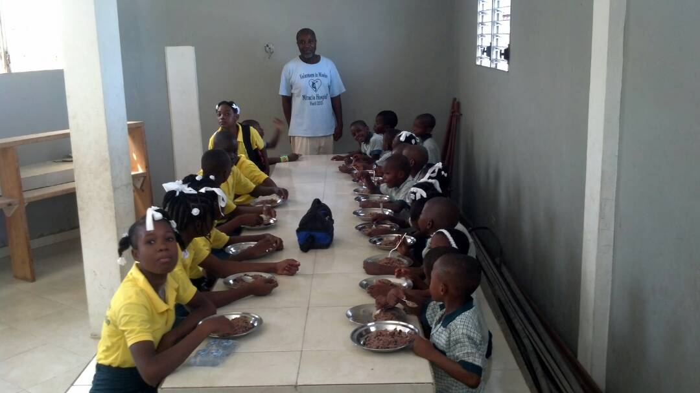
Some of our students in the cafeteria with Jean Filostin.
Other news bullets:
- The second year of university is beginning in October after a September break.
- Progress is being made on covering the cistern, with over $9000 raised in September.
- The Red church van is out of customs, but needing a new alternator. Ministry in the third world is challenging, but with your support, we are seeing real progress. The van will be an improved ride for picking up teams at the airport.
- Planning for teams in 2018 has begun. As team leaders determine dates, we will pass along that information so that others can be a part of this ongoing ministry. It is a blessing to meet these children and the many other people being helped and encouraged in Merger.
- Pray for Jean while he is in Haiti, that God will bless his efforts.
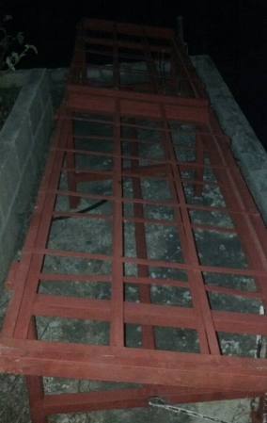
- Pray for the school as we add new teachers and M. Rosalyn recovers.
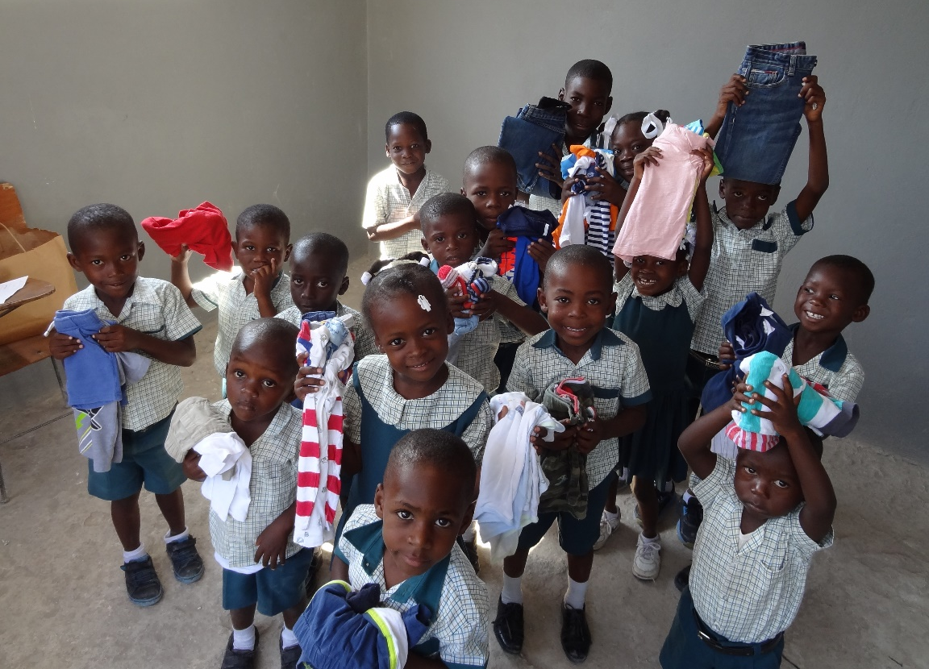
Solar panel cages: David is planning a November trip after cancelling his September trip in the aftermath of Hurricane Irma and with Hurricane Maria rapidly headed on the same path. Haiti was spared, but the impact on Florida (Irma) and Puerto Rico (Maria) and other areas has been extreme. David is looking forward to setting up the solar panels in November as we now have all the parts in place. If anyone wants to come along, he is looking at November 1-8 for the trip.

Some of the children with clothes brought down by a team.
They are so blessed and thankful for the support you all give them.

The IOG employs Haitians in the local communities, making all this possible. Without contributions from the United States, the school and university would not be able to reach all the students, so funding is a critical component of this ministry.
Contributions can be sent to:
Institute of Grace
P.O. Box 2364
Leesburg, VA 20177
Or contact David Graves for information about setting up a direct contribution.

Thanks for your prayers and support!

